Distributed File System(DFS)

The Distributed File System is used to build a hierarchical view of multiple file servers and shares on the network. Instead of having to think of a specific machine name for each set of files, the user will only have to remember one name; which will be the 'key' to a list of shares found on multiple servers on the network. Think of it as the home of all file shares with links that point to one or more servers that actually host those shares. DFS has the capability of routing a client to the closest available file server by using Active Directory site metrics. It can also be installed on a cluster for even better performance and reliability. Medium to large sized organizations are most likely to benefit from the use of DFS - for smaller companies it is simply not worth setting up since an ordinary file server would be just fine.

**Understanding the DFS Terminology**  
It is important to understand the new concepts that are part of DFS. Below is an definition of each of them.

**Dfs root:**You can think of this as a share that is visible on the network, and in this share you can have additional files and folders.

**Dfs link:** A link is another share somewhere on the network that goes under the root. When a user opens this link they will be redirected to a shared folder.

**Dfs target (or replica):** This can be referred to as either a root or a link. If you have two identical shares, normally stored on different servers, you can group them together as Dfs Targets under the same link.  
  
The image below shows the actual folder structure of what the user sees when using DFS and load balancing.

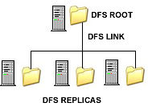

Windows 2003 offers a revamped version of the Distributed File System found in Windows 2000, which has been improved to better performance and add additional fault tolerance, load balancing and reduced use of network bandwidth. It also comes with a powerful set of command-line scripting tools which can be used to make administrative backup and restoration tasks of the DFS namespaces easier.

**Setting Up and Configuring DFS**

The Distributed File System console is installed by default with Windows 2003 and can be found in the administrative tools folder. To open, press Start > Programs > Administrative Tools > Distributed File System or in the Control Panel, open the Administrative Tools folder and click on the Distributed File System icon. This will open the management console where all the configuration takes place.  
  
The first thing you need to do is create a root. To do this, right click the node and select New Root.  
Press next on the first window to be brought to the screen where you will have to make the choice of creating either a stand alone or domain root. A domain root will publish itself in Active Directory and supports replication, whereas a stand alone root does not. If you have an AD Domain Controller set up on your machine, I recommend choosing the domain root.  
  
**Note:** The root would be the top level of the hierarchy. It is the main Active Directory container that holds Dfs links to shared folders in a domain. Windows 2003 allows your server to have more than one root - which wasn't the case in Windows 2000.

The next screen is the one where you have to select which trusted domains will be hosted. Since I only have one domain in my network, only domain.com is visible.   
  
Once this is done you have to select a server on that domain - in my example it is netserv. The FQDN (Fully Qualified Domain Name) of this host server is netserv.domain.com.

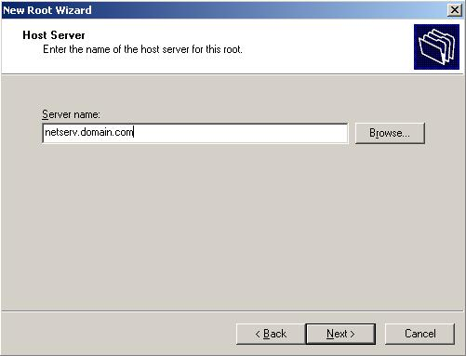  
**Figure 2:** inputting the host server name

The following screen allows you to specify the root name of your primary DFS root. You should give it something which will accurately define the contents of that share.   
In my example I have called this root "Company" - which would be a real name of an ogranization. You can change this to anything you want. You might wish to have a root called "Documents" - which would clearly state that one can expect to find anything related or specific to documents, and documentation in that root.

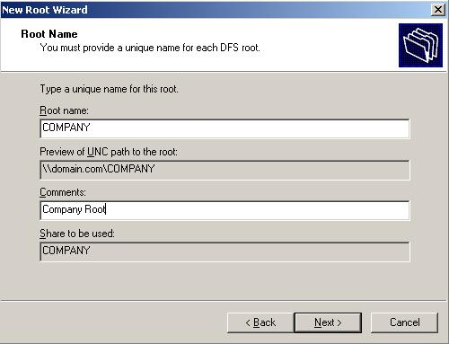  
**Figure 3:** entering the dfs root name

You will now have to select the location of a folder in which all the files will be stored.

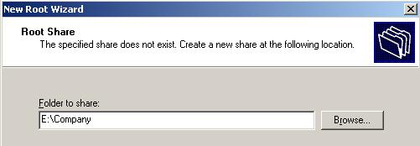  
**Figure 4:** selecting the root share

**Tip:**for added security, when selecting a folder, try to choose one that is located on a partition other than that of the operating system.  
  
Your DFS root is now configured and visible in the configuration console. Right click the root target and press Status to check if it is online or not.   
A green check mark verifies that everything is working properly and that the node is online, whereas a red X means that there is a problem.

To add a new link, right click the root for which you want the link to be created, and select New Link.  
In the "New Link" screen, enter a name and path for the link and click OK. Repeat this for as many links as you need to create.

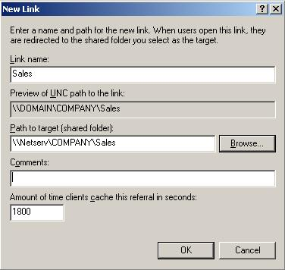  
**Figure 5:** creating a new link

Links are visible right under the node. Below is a screenshot displaying the three links I have created for the COMPANY root.

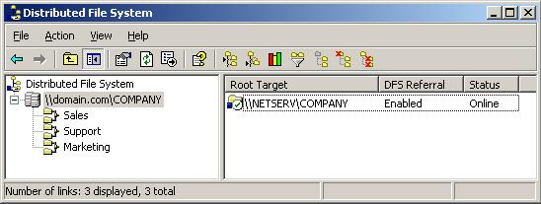  
**Figure 6:** dfs root and three links in the DFS mmc console

**Publishing the root in Active Directory**By publishing dfs roots in AD as volume objects, network users will be able to search for shares more easily and administration can be delegated.

To do this right click the desired dfs root, select Properties and go to the Publish tab. Enter the appropriate details in each box and press OK.  
In the keywords section you can specify certain words that will help locate the dfs root when it is being searched for.

**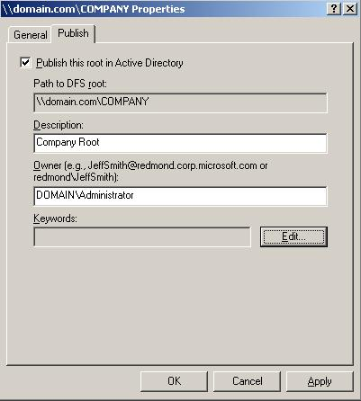  
Figure 7:** publish tab in the dfs properties window

The dfs root will now be published in Active Directory.

**File Replication Services**

There are two types of replication:   
  
* Automatic - which is only available for Domain DFS   
* Manual - which is available for stand alone DFS and requires all files to be replicated manually.  
  
The four ways in which replication can be achieved between two or more servers are:  
  
- Ring  
- Hub and Spoke  
- Mesh  
- Custom  
  
The first three refer to network topologies and the last allows you to specify an advanced method of replication, which can be tuned to your needs.

The advantages and disadvantages of replication are as follows:  
  
**Advantages**- client caching, integration with IIS, easy to administer and setup.

**Disadvantages** - limited configuration options, there is no method of programmatically initiating a replication session.

We have seen how with the use of the Windows 2003 Distributed File System, one is able to manage data more efficiently.

What used to be DFS in Windows 2000 and Windows Server 2003 is now two separate components in Windows Server 2003 R2:

* **DFS Namespaces -** This component allows you to create a namespace, which is a virtual free of shared folders located on different servers.
* **DFS Replication -** This component allows you to replicate the contents of shared folders using a new replication engine that replaces the File Replication Service (FRS) used by DFS in Windows 2000. Note that FRS is still used for replicating SYSVOL on domain controllers however.

The simplest way of installing these new DFS components is to use the Manage Your Server Wizard to add or upgrade the File Server role. Doing this installs the new DFS Management console and provides you the option of installing DFS Replication also if desired (Figure 1):

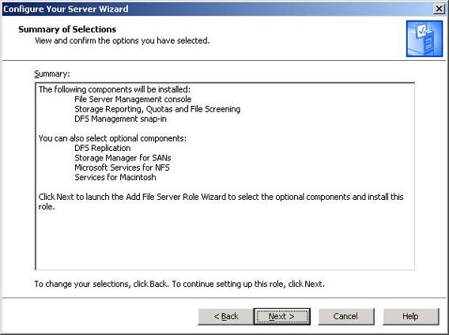  
**Figure 1:** Installing DFS using the Manage Your Server Wizard

If you only want to implement DFS Namespaces, you don’t need to install the additional DFS Replication component (I’ll cover DFS Replication in a future article on WindowsNetworking.com). In addition, if you want to take advantage of all the R2 enhancements to DFS Namespaces, you should ensure that:

* All servers that host namespaces are running Windows Server 2003 R2 (or at least SP1).
* All domain controllers are running SP1 or later.
* All servers from which you plan on performing DFS namespace management tasks are running SP1 or later.
* In addition, all desktop computers that will be accessing your namespaces should be running Windows XP SP2 or later.

**Creating a Namespace**

Let’s use the new DFS Management console to create a new namespace. Our new namespace will be domain-based, that is, rooted at the domain (standalone namespaces are also supported and will be discussed later). Here’s the scenario we’re going to use for our example:

* The Accounting department uses two file servers, BOX 162 and 163.
* BOX162 hosts the following shares: Payables and Receivables.
* BOX 163 hosts the following shares: Invoices, Inventory, and Reports.

The department wants to use DFS Namespaces to consolidate these resources into a single virtual folder tree that looks something like this:

Accounting  
            Ledger  
                        Accounts Payable (maps to Payables share)  
                        Accounts Receivable (maps to Receivables share)  
            Catalog  
                        Inventory (maps to Inventory share)  
            Billing  
Invoices (maps to Invoices share)  
            Report Database (maps to Reports share)

For purposes of this example, we’ll create our namespace on BOX162 on which we’ve installed the DFS Management console using the procedure outlined in the previous section. Start by opening the DFS Management console on this server and select the Namespaces node in the console tree (Figure 2):

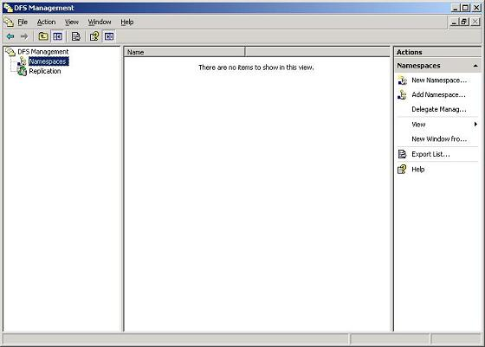  
**Figure 2:** Namespaces node in DFS Management console

Note that there are no namespaces until we choose to create one. To create a namespace, click New Namespace in the Action pane or right-click the Namespaces node and select New Namespace. The New Namespace Wizard starts and asks you to specify the server that will host your new namespace. Since we’ve installed DFS Namespaces on BOX162 we’ll use this server to host our namespace (Figure 3):

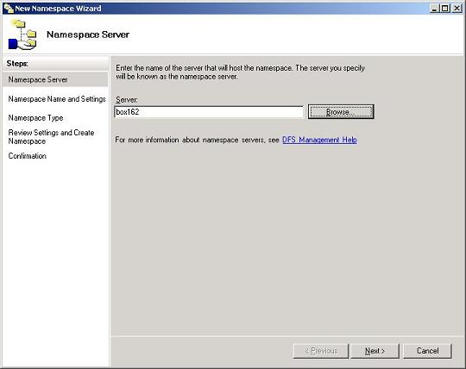  
**Figure 3:** BOX612 will host the new namespace

Click Next to proceed with the wizard. If the DFS service is not running on BOX612, you’ll now be prompted to start it. Next you’ll specify a name for your namespace, and considering the requirements of the Accounting department previously, we’ll name our new namespace “Accounting” (Figure 4):

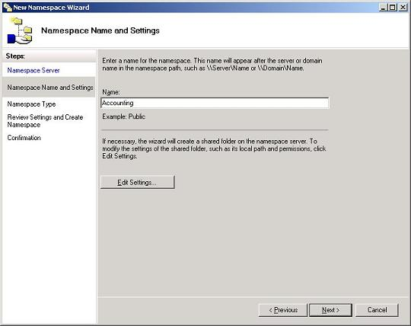  
**Figure 4:** The new namespace will have the name Accounting

Note that we didn’t previously create an Accounting share on this server, so the wizard will create this for us. Click Next and select domain-based namespace as the type of namespace we want to create (Figure 5):

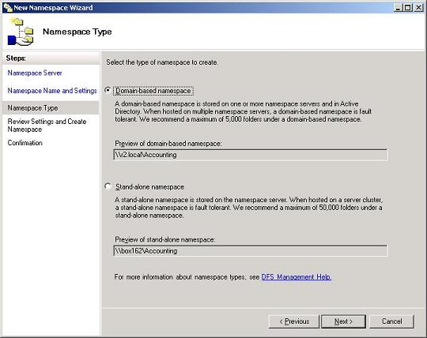  
**Figure 5:** Selecting domain-based namespace

A quick aside here concerning namespace types:

* **Domain-based namespaces -** These namespaces are stored on both your namespace servers and within Active Directory. Storing namespaces in Active Directory makes them easier to search for in a domain-based networking environment, but the size of domain-spaced namespaces is limited to around 5000 folders. Also, a domain-based namespace can be hosted on more than one namespace server to provide fault tolerance.
* **Standalone namespaces -** These namespaces are stored only on name servers and not within Active Directory. The advantage of this approach is that you can host ten times more folders (up to 50,000 folders) in your namespace, but to make your namespace fault-tolerant you have to use clustering since a standalone namespace can only be hosted on a single server.

Clicking Next and then Create will create a new namespace named Accounting in the R2.local domain of our sample forest. This namespace will be rooted in a shared folder named C:\DFSRoots\Accounting on BOX162, and this root folder will also be created by the wizard shared with Everyone being given Read permission. Figure 6 shows the new namespace, which as yet has no folders in it:

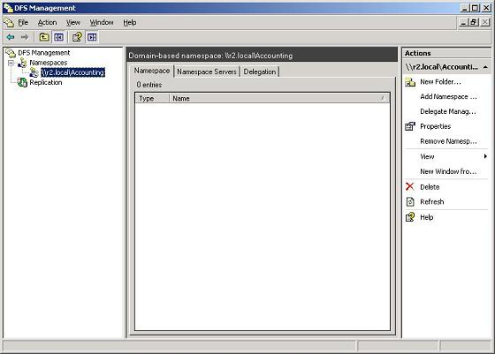  
**Figure 6:** The new Accounting namespace in the R2.local domain

**Adding Folders to the Namespace**

Now let’s add our folders to the namespace. There are two kinds of folders we need to add:

* **Folders with targets -** These are virtual (DFS) folders that map to real (physical) shared folders. For example, the folder Accounts Payable folder needs to have the Payables share on BOX162 as its target, the Report Database folder needs to have the Reports share on BOX163 as its target, and so on.
* **Folders -** These are virtual folders that don’t map to any real shared folders on the network but are simply used to organize how shared resources are presented to users by the namespace. For example, the Ledger folder needs to be created to contain the Accounts Payable and Accounts Receivable folders, which are both folders with targets located on BOX612.

To create a new folder in our Accounts namespace, select the namespace in the console tree and click New Folder in the Action pane or right-click the namespace and select New Folder. This opens the New Folder properties sheet, which lets you specify a name for your new folder and optionally a target. For example, to create the Ledger folder which has no target, enter the information shown in Figure 7:

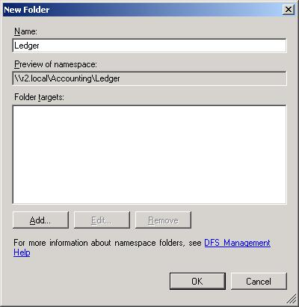  
**Figure 7:** Creating a folder with no target

Then select the Ledger folder in the console tree, click New Folder again, and create the Accounts Payable folder as shown in Figure 8:

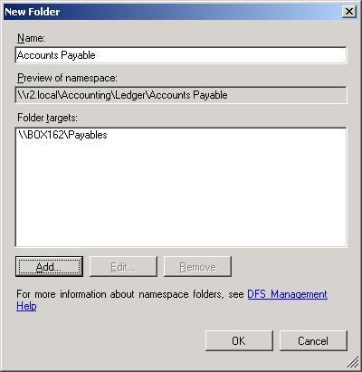  
**Figure 8:** Creating a new folder with a target

Continue creating folders, with and without targets, until the desired namespace is complete (Figure 9):

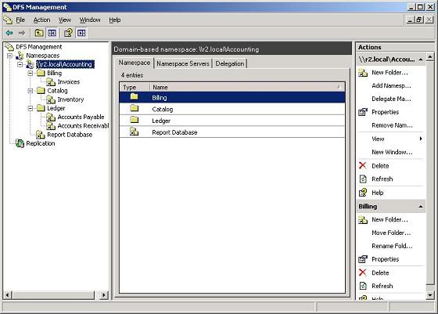  
**Figure 9:** Finished namespace for the Accounting department

**Testing the Namespace**

To try accessing resources in our new namespace, we’ll log on as ordinary user Bob Smith to a desktop computer running Windows XP. Then, once logged on, we’ll click Start, then Run, type \\R2.local\Accounting (which is the root of our namespace) and click OK. This opens a window that displays four folders (Billing, Catalog, Ledger and Report Database) as if they are shared folders on a single server (Figure 10). By clicking into each of these folders we can access further folders and the documents stored within their target folders.

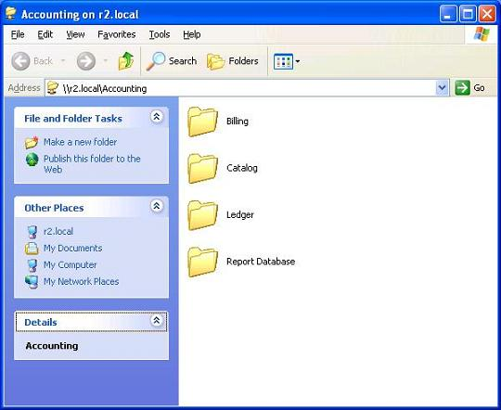  
**Figure 10:** Viewing the namespace and its contents

**Conclusion**

It’s easy to use the DFS Management console to create a new namespace that brings together shared folders from multiple file servers into a single virtual folder tree. In my next article we’ll look deeper into DFS Namespaces and see how to further configure a namespace and its folder in a multi-site environment.